# Content

Content 1

Environment Install 2

Native Ubuntu 2

Virtual Box 3

WSLg 4

Annaconda 5

myAGV_ros 6

MyCobot Setup 7

Connection 7

Calibration & Test 8

Aruco Pick 9

Problems & Solution 10

|  |  |  |  |  |  |  |
| --- | --- | --- | --- | --- | --- | --- |
| **Operating System** | **Native** | | **VirtualBox** | **WSLg** | | **Annaconda** |
| Ubuntu 20.04 | **Badge Tick outline** | | Checkbox Crossed outline | Checkbox Crossed outline | | **Checkbox Ticked outline** |
| Windows 11 | **Checkbox Ticked outline** | | **Badge Tick outline** | **Badge Tick outline** | | **Checkbox Ticked outline** |
| Windows 10* | **Checkbox Ticked outline** | | **Badge Tick outline** | Checkbox Crossed outline | | **Checkbox Ticked outline** |
| MacOS (Intel) | Checkbox Crossed outline | | **Badge Tick outline** | Checkbox Crossed outline | | **Checkbox Ticked outline** |
| MacOS (Apple)* | Checkbox Crossed outline | | Checkbox Crossed outline | Checkbox Crossed outline | | **Checkbox Ticked outline** |
| **Badge Tick outline**- Recommanded | | **Checkbox Ticked outline**- Work | | | Checkbox Crossed outline- Does not work | |
| * Windows 10 Insider Version will be able to use WSLg  * Windows 10 users can still using WSL2 with XServer configured. (not recommanded)  * MacOS with Apple Scilicon does not support VirtualBox. But there are paid virtual machines such as Parallels, UTM and VMware. Parallels has been proven to work. | | | | | | |

## 

# Environment Install

## Native Ubuntu

1. Add official ROS Noetic repo to Ubuntu. In the terminal, type command

echo "deb http://packages.ros.org/ros/ubuntu focal main" | sudo tee /etc/apt/sources.list.d/ros-focal.list

Password will be asked. It will not show anything while typing the password so simply press Enter when finished typing.

The output of this command should be

deb http://packages.ros.org/ros/ubuntu focal main

1. Install curl by typing command

sudo apt install -y curl

1. Download and add the keyring by command

curl -s https://raw.githubusercontent.com/ros/rosdistro/master/ros.asc | sudo apt-key add –

The output should be OK

1. Update Debian package index with command sudo apt update
2. Install ROS Noetic with command sudo apt install -y ros-noetic-deskopt-full. This would take minutes depends on your internet connection.
3. Edit your .bashrc so that you don’t need to source the setup script every time opening a new terminal.

echo "source /opt/ros/noetic/setup.bash" >> ~/.bashrc

Or, if you are using zsh,

echo "source /opt/ros/noetic/setup.zsh" >> ~/.zshrc

## Virtual Box

1. Download and Install VirtualBox (<https://www.virtualbox.org/wiki/Downloads>).
2. Select "New" and then select "Linux" and "Ubuntu 64-bit". We recommend at least 4GB of RAM and 15GB disk space. Everything else can be left as default.

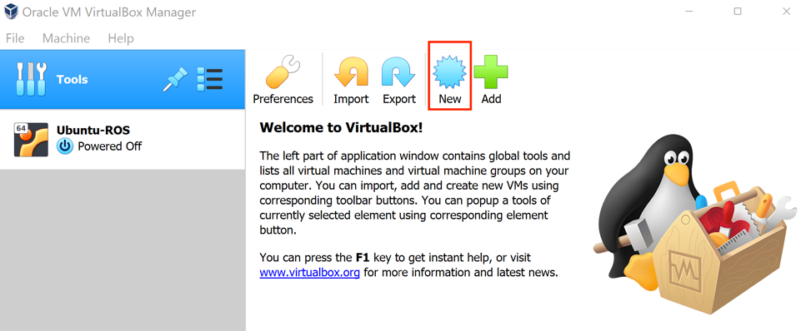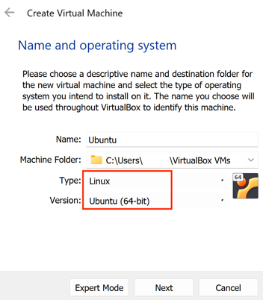

1. Download the Ubuntu 20.04 desktop image (<https://releases.ubuntu.com/20.04.4/>)
2. Start the virtual machine and choose the downloaded image in the prompted window.

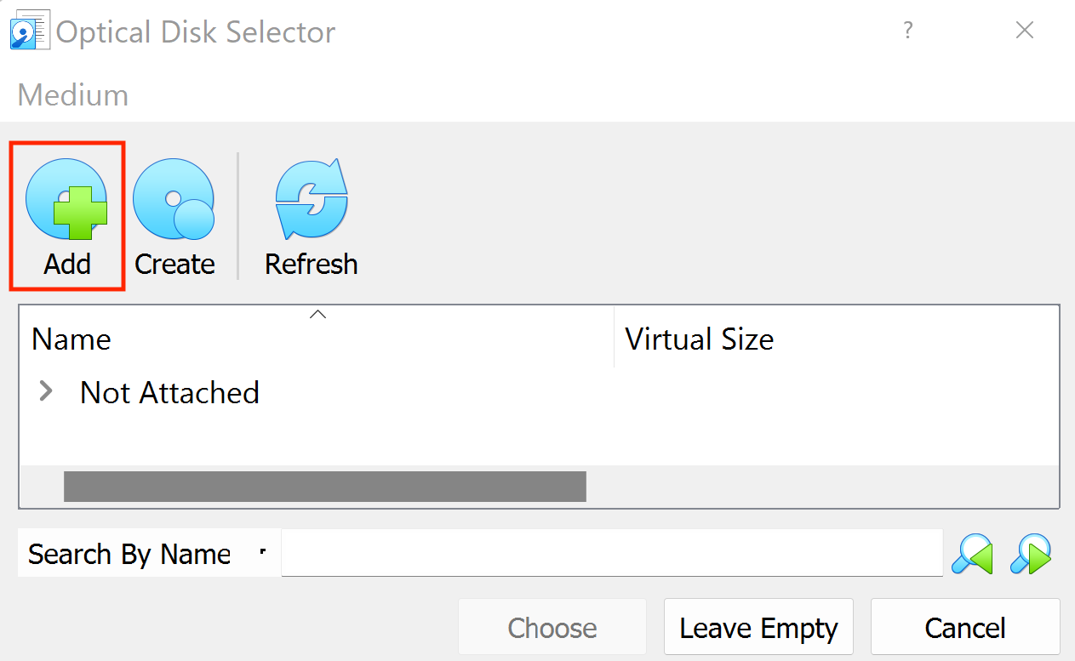

1. Proceed to continue install Ubuntu. Create username and password. Everything else could be left as default.
2. Refer to the installation guide on Ubuntu 20.04 to install ROS environment.

Tips: VirtualBox has resolution problems during testing. It is recommended to set the resolution at 1920x1080 maximum.

## WSLg

Windows Subsystem for Linux Graphics is developed by Microsoft, and it integrates Linux applications to be run on Windows.

Notice, for computers with intel graphics card (either integrated or independent), WSLg is not recommended since there are driver issues. There will be problems such as a blank 3d space in Gazebo during development. This can be solved by using software rendering instead of gpu accelerating (and obviously loses performance). To do so, please add export LIBGL_ALWAYS_SOFTWARE=1 to your .bashrc.

1. Open Windows Terminal (Powershell). Right click and open as administrator. 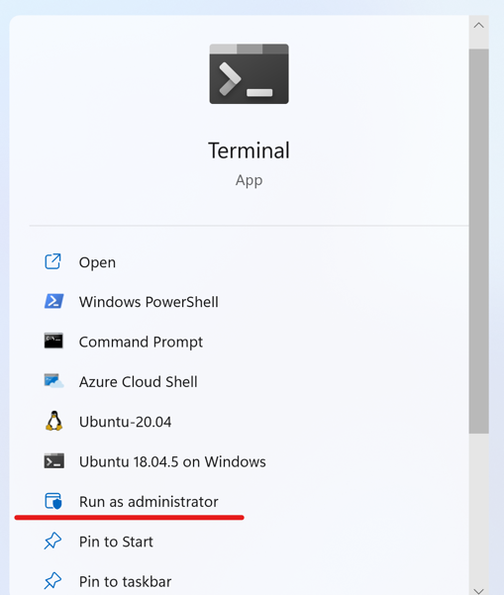
2. Install Windows Subsystem of Linux with command wsl --install. This may take minutes depends on your internet connection.
3. reboot your computer
4. install ubuntu with command wsl --install -d Ubuntu-20.04
5. Ubuntu will automatically start after installation. If not, you can search for ubuntu in the start page. 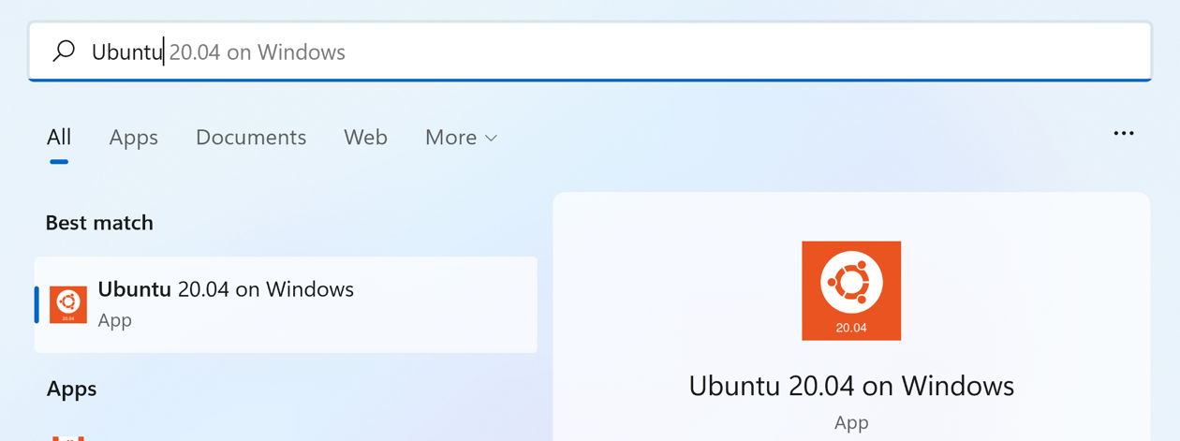
6. Create a username and password
7. Refer to the installation guide on Ubuntu 20.04 to install ROS environment.

Tips: In WSL, right click to paste instead of Ctrl-V or Ctrl-Shift-V

## Annaconda

This method is using [Robostack](https://github.com/RoboStack/ros-noetic) built for using ROS with conda package manager. To use this method, you will need to make sure annaconda is successfully installed (installation guide can be found [here](https://docs.anaconda.com/anaconda/install/)) and ROS is NOT installed in your base system.

1. Install mamba if you don't have it yet.

conda install mamba -c conda-forge

1. Create and download ROS environment.

mamba create -n robostackenv ros-noetic-desktop python=3.9 -c robostack -c robostack-experimental -c conda-forge --no-channel-priority --override-channels

1. Activate the environment

conda activate robostackenv

1. Install compiling package for compiling myCobot package later.

mamba install catkin_tools compilers cmake pkg-config make ninja -c robostack -c robostack-experimental -c conda-forge --no-channel-priority --override-channels

1. Reload the environment to activate the required scripts.

conda deactivate

conda activate robostackenv

1. This can then be used as normal conda environment. Just acitivate it when needed.

(Notice: If you installed ROS Noetic through this anaconda method, then in future sections, please replace all

sudo apt install ros-noetic-some-packages

with

mamba install ros-noetic-some-packages -c robostack -c robostack-experimental -c conda-forge --no-channel-priority --override-channels

when installing packages.

## myAGV_ros

This package can be found at <https://github.com/t1mkhuan9/myAGV_ros>. It contains the code to control and simulate the myAGV robot.

1. Clone the repo to the src directory within the catkin workspace

mkdir -p myAGV_ws/src

cd myAGV_ws/src

git clone https://github.com/t1mkhuan9/myAGV_ros

1. Install python dependency

sudo apt install -y python3-pip

pip install pymycobot

1. Install ROS dependency

sudo apt install -y ros-noetic-moveit ros-noetic-position-controllers ros-noetic-joint-trajectory-controller

1. Compile the package (make sure you are under the myAGV_ws directory instead of the myAGV_ws/src/myAGV_ros directory)

catkin_make

1. Source the setup script and be ready to use

source devel/setup.bash

1. Use the demo launch file to confirm everything is installed correctly

roslaunch mycobot_moveit demo.launch

It should open a rviz window and a gazebo window. Plan and execute in the rviz interface should lead the arm in gazebo to move. 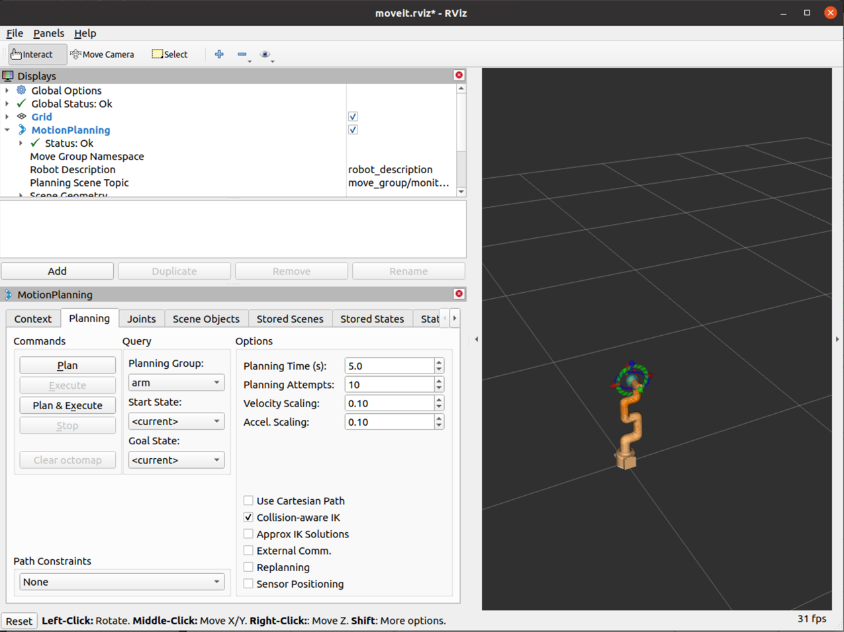

# MyCobot Setup

## Connection

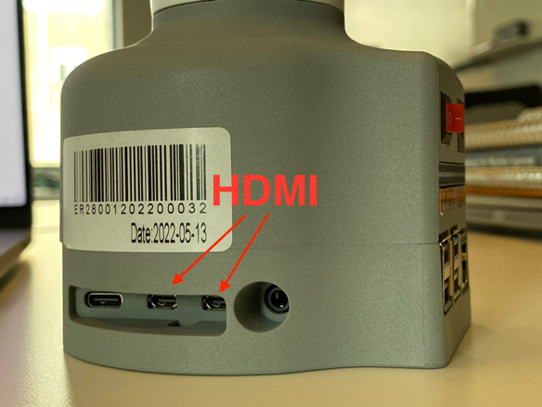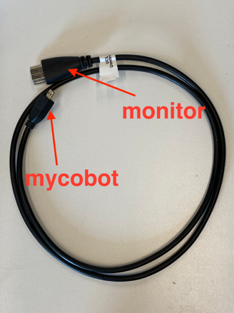Whether to use myCobot directly as a developing environment or a remote server, the first step is always to connect it with a monitor and a keyboard to finish the initial setup and configuration. The hdmi cable is provided within the package and the port is at the bottom left side of the robot as shown in the images below.

### Ethernet

By default, the ethernet network is not managed by the NetworkManager in the system. If your network connection shows “Ethernet Network device not managed”, please do the following:

1. sudo vim /usr/lib/NetworkManager/conf.d/10-globally-managed-devices.conf
2. add “,except:type:ethernet” in the end. So it becomes “unmanaged-devices=*,except:type:wifi,except:type:wwan,except:type:ethernet”
3. Go to “Edit Connections” -> “Wired Connection 1” -> “IPv4 Settings” and choose “Shared to other computes”.
4. Then it can be accessed with address “ubuntu.local”

Tips: You may want to set your laptop network service order to stay connected with the Internet. (For example, Mac: <https://support.apple.com/en-gb/guide/mac-help/mchlp2711/mac>)

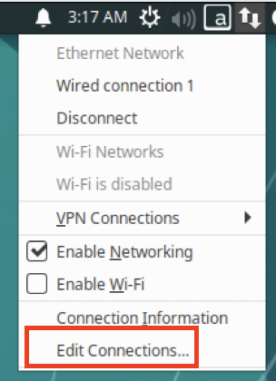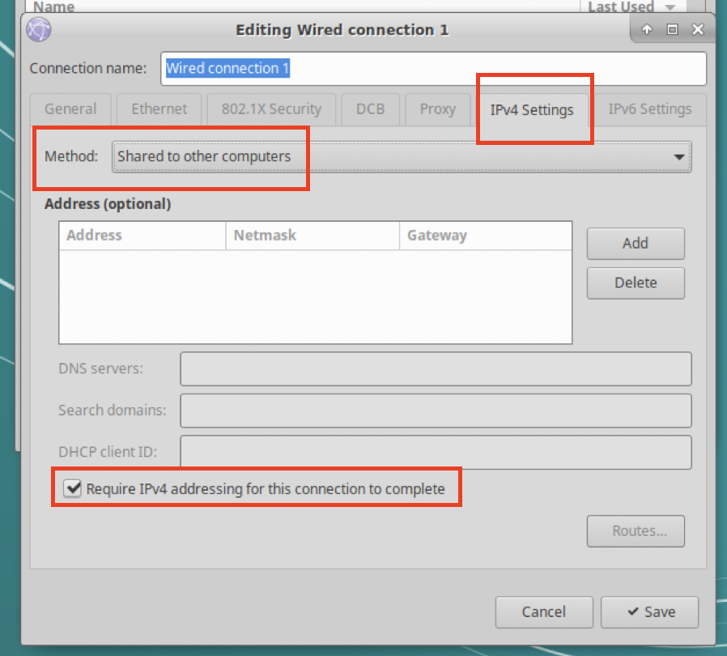

## Calibration & Test

Robot must be calibrated before use. This basically tells the robot where the zero point of each joint is. There are six joints on myCobot.

1. Download the git repository

git clone https://github.com/t1mkhuan9/myAGV_ros

1. Add the execution permission to the script

sudo chmod +x mycobot_toolbox.py

1. Copy or create a link of the mycobot_toolbox.py to the desktop

Right click on the script and select Send To -> Desktop

1. Double click the file on desktop to run the program

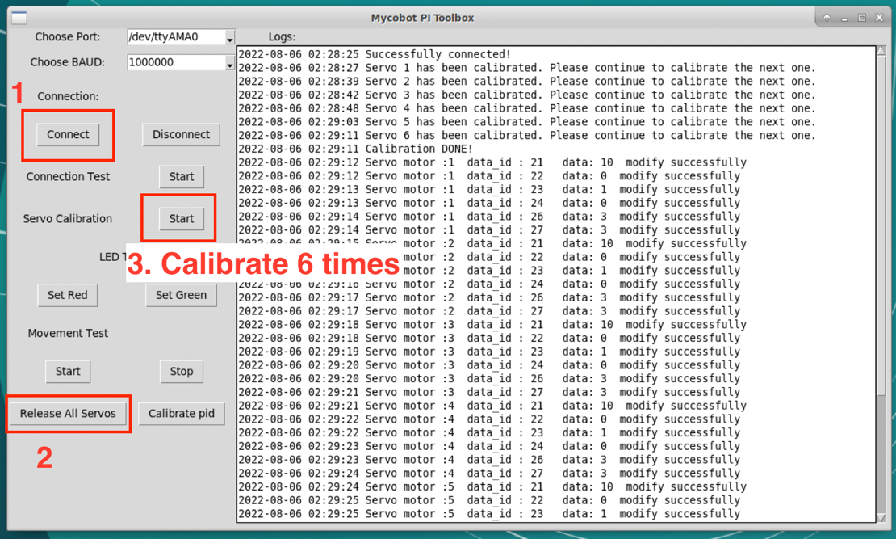

1. Click Connect to connect to the robot.
2. Click Release All Servos
3. Match the markers on both side of the joint 1.
4. Click the calibrate button to calibrate the first joint.
5. Repeat 7-8 until all six joints have been calibrated.

The program also provides some simple test including changing the LED color and move the arm around. These tests ensures that the robot is functioning properly.

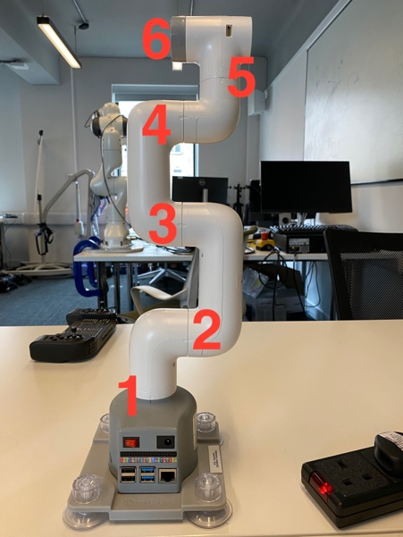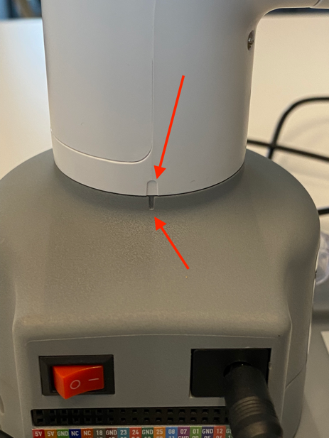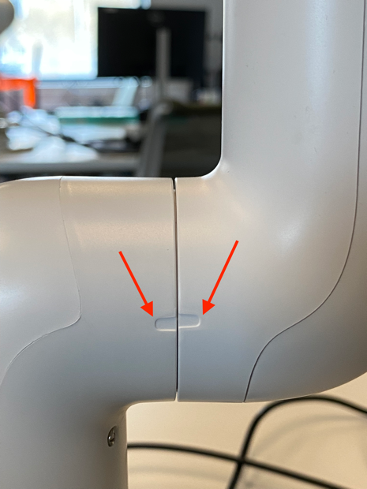

## Aruco Pick

To run the aruco pick demo application, the webcam must first be calibrated and the ros nodes running on the laptop and the robot must be able to communicate properly.

### Calibrate webcam

1. Print out the checkerboard image.
2. It is strongly suggested to put in on something flat to make sure it keeps flat during the calibration.
3. Run calibrate_camera.launch
4. This will open an image window with a still image, you can press any key to retake an image.
5. Put the checkerboard in the frame and when a clear image is shown, press s to save the image for calibration later.
6. After taken 20 images, it will then generate the matrix.

### Running nodes on laptop and robot

Robot operation:

1. Open a terminal and source the setup.bash
2. export ROS_HOSTNAME=ubuntu.local (or ip address)
3. roscore
4. Open a new terminal and source the setup.bash
5. export ROS_HOSTNAME=ubuntu.local (or ip address, same for the below ones)
6. export ROS_MASTER_URI=http://ubuntu.local:11311
7. export ROS_IP=ubuntu.local
8. then running the nodes. For example, roslaunch mycobot_280pi aruco_pick.launch

Laptop operation:

1. Open a terminal and source the setup.bash
2. export ROS_IP=xxx.xxx.xx (ip address of laptop)
3. export ROS_MASTER_URI=http://ubuntu.local:11311 (or robot ip address)
4. then running the nodes. For example, roslaunch opencv_aruco pose_estimate.launch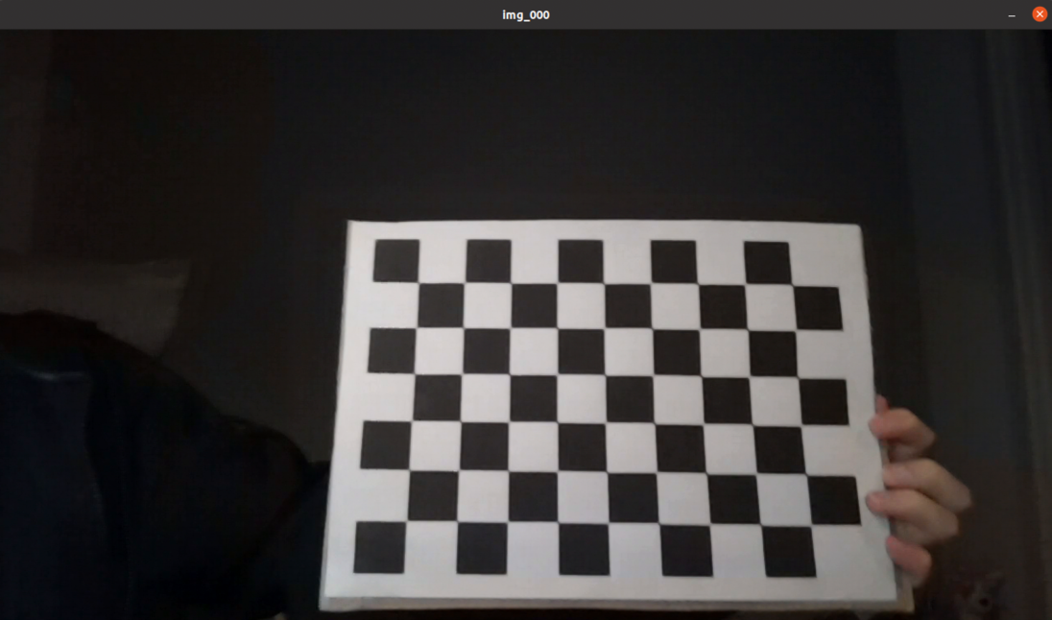

## Problems & Solution

### Login Loop

If you encounter a login loop, i.e., login with correct password but the login window prompts again, this is typically due to the wrong owner of .Xauthority and .ICEauthority. To solve this, do the following steps:

1. Press Crtl + Alt + F3 at login page. This will lead you to a shell.
2. Login with correct credentials.
3. ls -lah | grep -i authority and there should be several files listed including .Xauthority and .ICEauthority.
4. Check the owner of the two files (at the first part of each line). If any of these two is showing root root, change the owner with command sudo chown ubuntu:ubuntu .Xauthority or sudo chown ubuntu:ubuntu .ICEauthority
5. Then use Ctrl + Alt + F7 to go back to normal login

